# Supporting Code Samples

## Support code for connecting to the database

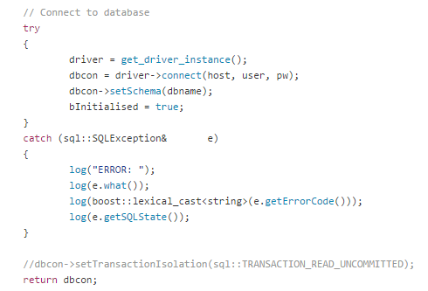

## Support for utilities for logging debug info

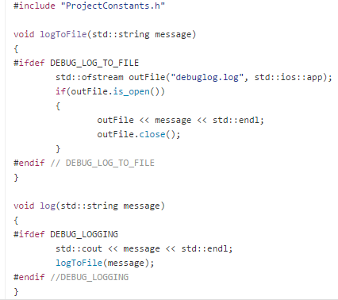

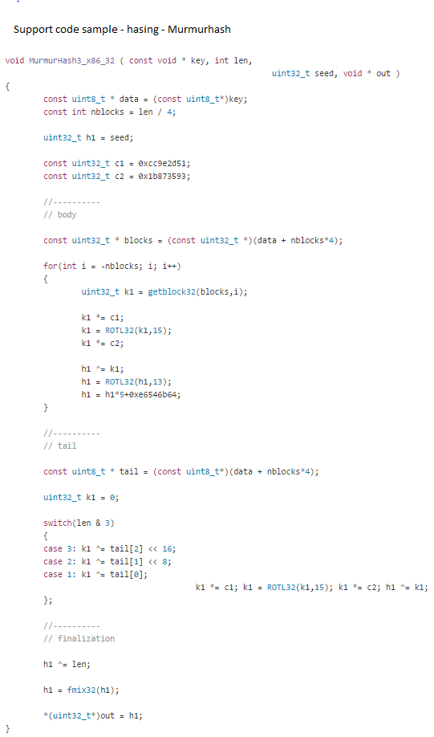

# Unit Testing Samples

## Testing for correctly appended path to file

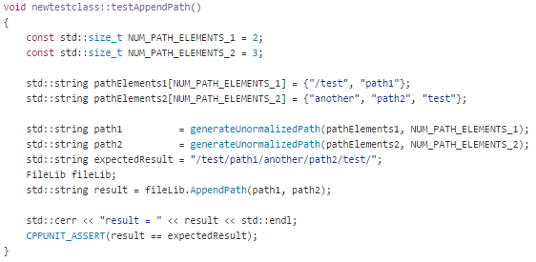

## Testing for retrieving filename functionality

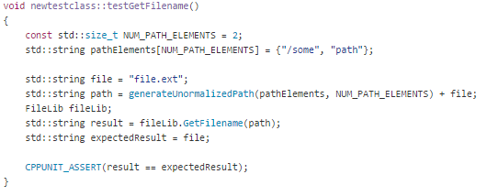

# Appendices

## Code Elements

* FileArchiver.cpp / FileArchiver.h
* FileLib.cpp / FileLib.h
* FileRecord.cpp / FileRecord.h
* CompressUtils.cpp / CompressUtils.h
* DBConfigurationFileUtility.cpp
* DBConnector.cpp / DBConnector.h